Problem 1
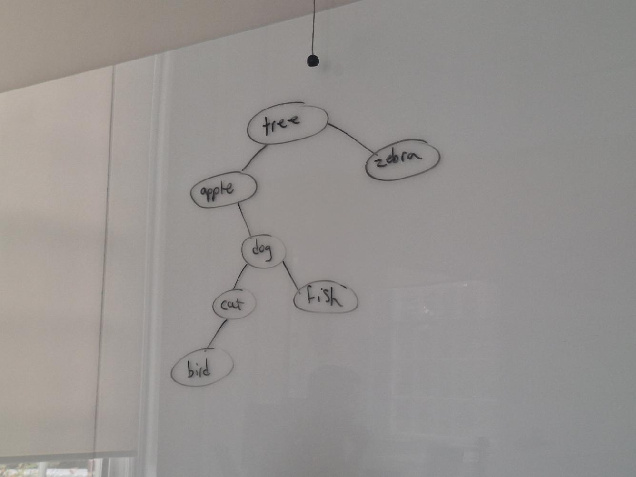
In-Order Traversal: apple, bird, cat, dog, fish, tree, zebra
Pre-Order: tree, apple, dog, cat, bird, fish, zebra
Post-Order: bird, cat, fish, dog, apple, zebra, tree

In-Order Traversal would sort the tree in alphabetical order since it would always go the a left node until the left node is null

Problem 2
Path to dog:
Dog < Tree, go to Apple
Dog > Apple, go to Dog
Dog == Dog

Path to elephant:
Elephant < Tree, go to Apple
Elephant > Apple, go to Dog
Elephant > Dog, go to Fish
Fish does not have any children, end search.

Maximum number of comparisons: 5
Average number of comparisons: 3 (5+4+4+3+2+2+1 = 21, 21/7 = 3)

Problem 3
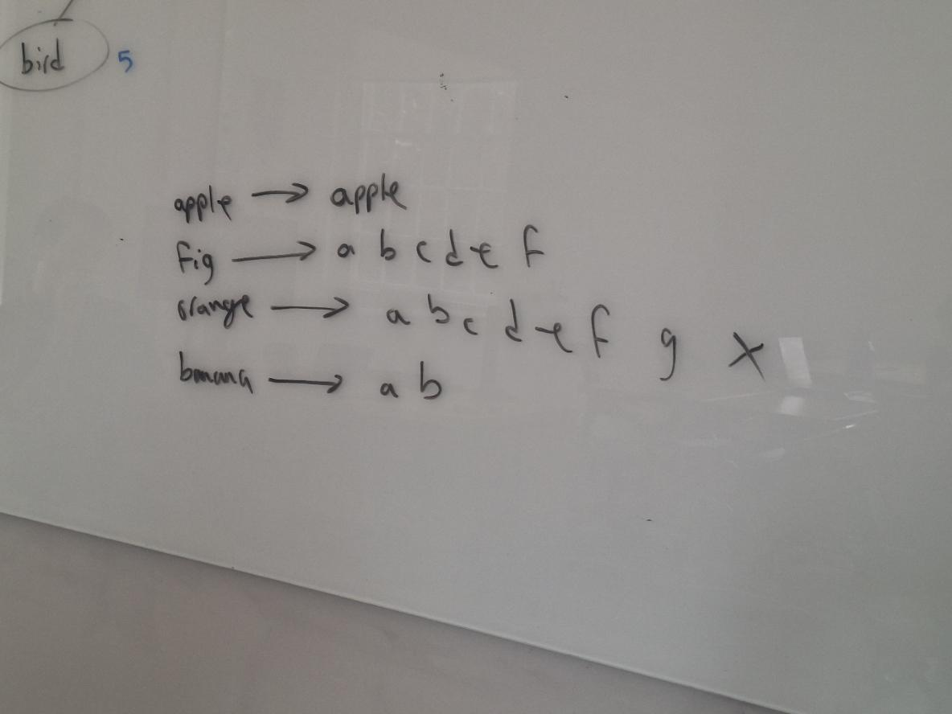

Time Complexity for worst case checking is O(n) since it would have to go through every node.
Best case would be O(1) assuming the word is the root.

